**Describe about your product?**

In today’s world, the most widely used motorcycles are gas powered. The prices of petroleum products have skyrocketed since a few months ago. So, the fuel powered bikes are not able to give the best cost per kilometer as they did a couple of years back. Also, the market of EV is not able to compete the traditional bikes as usually EV’s don’t have the same range as fuel powered ones especially because of the technological and physical limitations of battery. So, what we have planned is to produce a different kind of vehicle that is best of the both worlds i.e., Hybrid bike. Our main goal will be to effectively reduce the fuel consumption and giving similar or even more range and mileage with the help of this technology.

**What problem are you trying to solve?**

The main problem of todays motorbikes is that they consume a lot of fuel and then their average is 40 to 50 km per liter and its cost will be around 90 to 100 rupees. So, their cost per kilometer ratio is 2:1. When comparing this to the 0.15:1 of electric bike, it is very high. So, the main problem that we are going to solve is to reduce fuel consumption and decreasing the cost per km when using same amount of fuel.

**What is unique about your idea?**

The main unique feature of our product will be that it will be a direct drive bike which means that an alternator will be used to directly convert the fuel system’s mechanical energy into electrical energy to drive the motor attached to the tire using a suitable alternator. We will also be giving the feature to directly drive the motor through the bike’s battery for short range in case of emergency. This will enable our bike to run for greater distances then petrol bike while containing same amount of fuel. This will hugely reduce the fuel consumption and the fuel cost.

**What features will you offer?**

Using the gear shift indicator of the bike’s engine, we will give the same features like that of the petrol bike. For example: In 1st gear the petrol bike will opt for higher torque in the wheels instead of the speed. This will help to climb the steep roads or to ride in the offroad. Then the 2nd gear increases the speed while reducing the torque and respectively for the 3rd, 4th and any other higher gear. This means the highest gear will give the bike the higher speed while the lowest gear will give the torque. We will implement the same system. We will provide high power in 1st gear but the speed will be limited and then simultaneously increase the speed and decrease the torque while shifting to higher gears.

**What are the different techniques implemented?**

Our bike will use the same engine as the petrol bike. We will use a custom alternator to produce power from the bike’s engine. The power then will be transferred to the custom-made ECU. The ECU will then decide to switch power to the motor according to the gear it is given by the user. At idle/neutral gear, the ECU will then charge the battery of the bike which will then be used to power the bikes electronics as well as be used in the emergency situation. The same chassis will be used with some inhouse modifications to house the custom alternator and ECU. The drive shaft/belt/chain will be completely removed to allow the space to be used in other purposed for example: to route the cables.

**Explain the product/solution architecture.**

Generally, a traditional petrol bike has an engine that takes petrol from the fuel tank through the carburetor/fuel injector and burns the fuel to produce power through the crankshaft system inside it. The crankshaft then runs a series of components inside a torque converter which then transfers them into the wheels to spin with the help of chain/belt/shaft. So, what we will do is we will eliminate all the systems after the torque converter and connect it directly with a custom-made alternator replacing the old one. This means that the power of the engine will be used directly by the alternator and produce electric power. This power then will be sent to the hub motor attached to the wheel through the custom-made ECU that consists of couple of transformers that will provide the required power to the motor. This will result in a greater mileage and range when compared to the same system running with drive shaft system. This will then reduce the cost per kilometer of the product making it cheaper for the user.

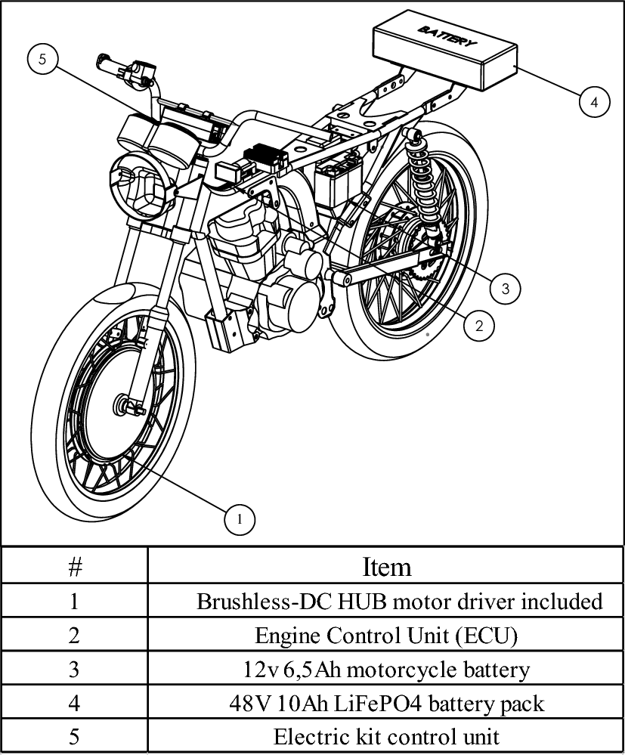

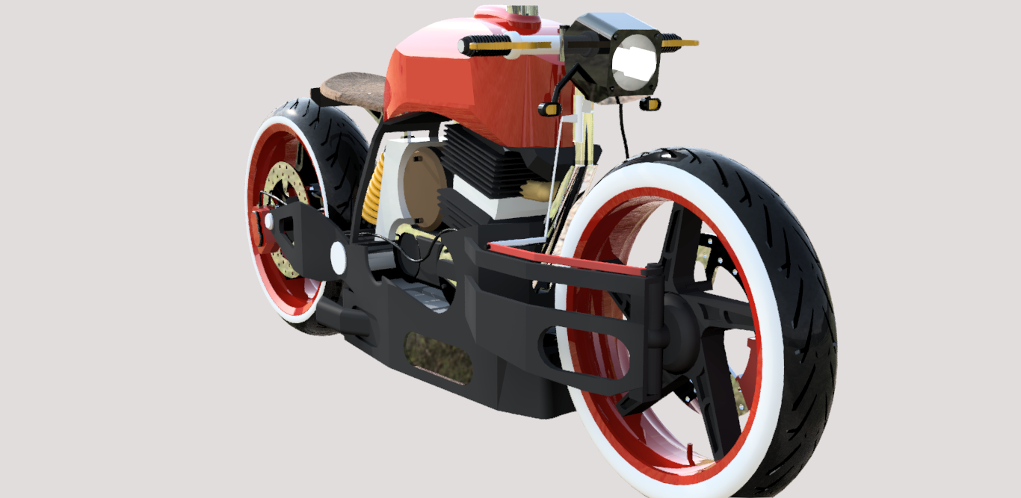**Any pictorial representation of your product?**